  - Vacuum Forming
Key Revision Facts: GCSE Technology

Vacuum Forming is a process in which heated plastic is shaped around a form by removing the air. The basic steps of the vacuum forming process are

- The plastic is heated
- Once hot, the solid former is pressed into the plastic from a bed that can rise
- The vacuum is turned on, removing all the air from around the former
- The plastic cools and takes the form of the solid former

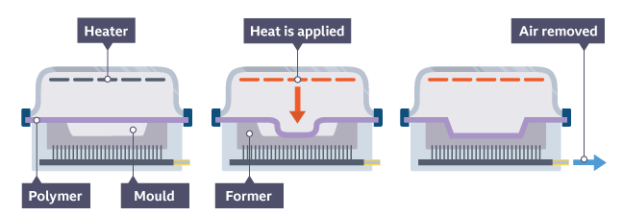

The solid shape that goes in the vacuum former is called a former; the hollow part that has been vacuum formed is called a mould.
The former must have a draft angle, so it doesn’t get stuck in the mould.
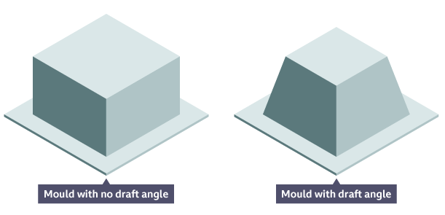

Download
More Key Fact Revision sheets can be downloaded from
www.andrew-seaford.co.uk/revision

Version information
Date | Arthur | Comment
13-Mar-2021 | Andrew Seaford | Initial release.

